**Week 3**

**Exercise 1** In this exercise I have created a function that welcome the employee and shows its salary

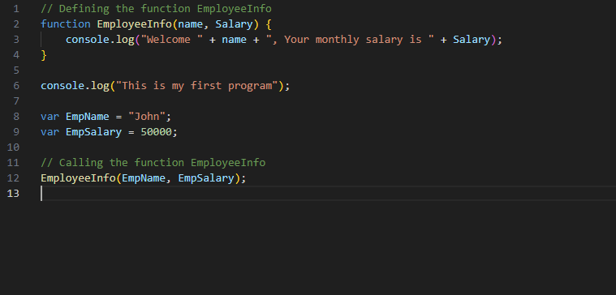

**Output  
  
**

**Exercise 2**

Created an arrow function

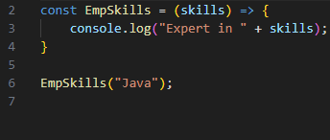

Output :



**Exercise 3**

Demonstrates JavaScript basics with EmployeeInfo and EmpSkills. Imports StudentInfo and Person modules for modularity and uses the os core module to display system information.

Local Module 1 (StudentInfo.js):

Defines and exports constants and arrow functions for student details and grading, showcasing module exports and parameterized functions.

Local Module 2 (Person.js):

Implements a Student class with modern JavaScript syntax and exports it using module.exports.

**StudentInfo.js**

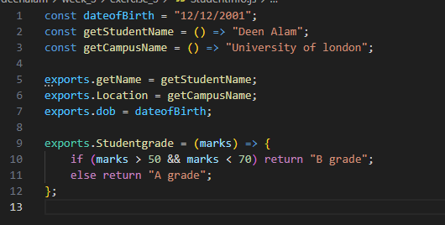

**Person.js**

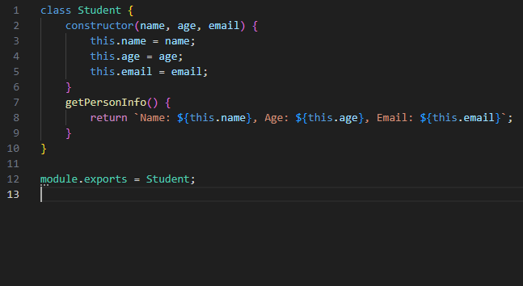  
  
**index.js  
  
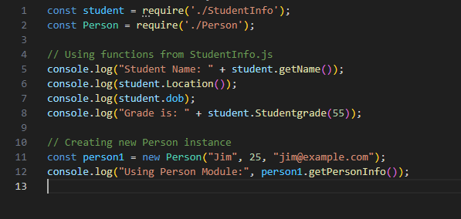**

Output:  
  
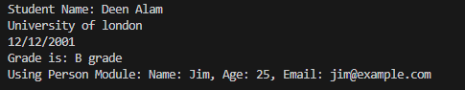

**Exercise 4**

Utilizes os and util modules to retrieve and display system information like memory, CPU, and uptime.

